Pokhara University

Level: Bachelor | Semester – Spring | Year : 2005
Programme: BE |  | Full Marks : 100
Course: Engineering Mathematics I |  | Time : 3hrs.

Candidates are required to give their answers in their own words as far as practicable.
The figures in the margin indicate full marks.

Attempt all the questions.

1. | - If a function f(x) is differentiable at x = a show that it is continuous at x = a. By taking proper example show that the converse may not be true.  OR  If y = (sin⁻¹x)², prove that  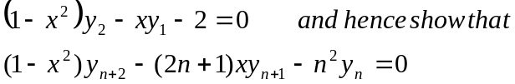  - State and prove Rolle’s theorem. For f(x) = (x)^{2/3} defined in [-8,8], explain whether Rolle’s theorem can be applied? | 8  7
2. | - Show that the semi-vertical angle of the cone of maximum volume of a given slant height is tan⁻¹().  OR  If 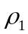and 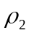 be the radius of curvature at the ends of Latus rectum of the parabola y² = 4ax, prove that 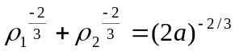  - Evaluate 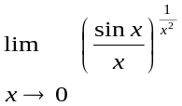 | 8  7
3. | Integrate Any Three of the following:  - 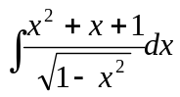  - 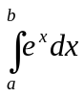 (by summation method)  - Show that 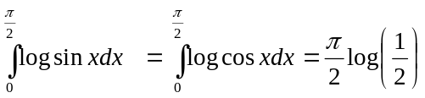  - 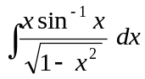 | 15
4. | - Find the area bounded by x² = 4y and the line y = |x|.  OR  Find the volume of the solid generated by revolving the region in the first quadrant bounded above by the parabola y = x², below by the x- axis and on the right by the line x = 2, about y – axis.  - Use Simpson’s rule with n = 4 to approximate the area between the curve y = 2x-1, ordinates at x = 1, x = 3 and x – axis. Also evaluate the same by using trapezoidal rule and hence compare these results with exact values. | 7  8
5. | - If 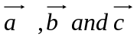 are coplanar show that  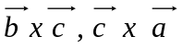 and 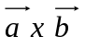are also coplanar.  - Find by vector method the equation of the plane through the points (1,2,3), (3,2,1) and perpendicular to the plane 4x – 2y + 2z – 7=0 | 8  7
6. | - Define conic section and classify them with respect to eccentricity. Obtain the equation of the tangent at (x₁, y₁) of the ellipse 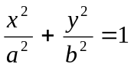.  - Find the condition that the line y = mx+c may be a tangent to the hyperbola 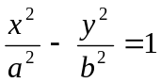. | 8  7
7. | - Evaluate 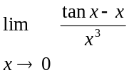  - Integrate 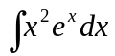.  - Find vertical and horizontal asymptotes of 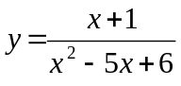  - If y = 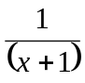 find y_{n} .  - Find vertex, focus and line symmetry of the parabola  (y + 1)² = 8(x + 1) | 2  2  2  2  2

